# Table of Contents

1. **Introduction 3**
   1. Purpose 3
   2. Objective 3
2. **Design Overview**
   1. Description of the Problem 4
   2. System Organization 4
   3. System Operation 5
3. **System Architecture 6**
   1. System Design 6
4. **Component Design 7**
5. **User Interface Design 8**
6. **Maintenance Scenarios 9**

# 1.0 Introduction

## 1.1 Purpose

This design document describes the high-level organization and individual components of the *Treasure Box Braille Authoring Application* software. The Authoring Application is an aid targeted towards creating, viewing, reading, manipulating and recording information for users that are visually impaired.

## 1.2 Objective

The Authoring Application is an application that operates as a workspace for users to view, edit and create TBB scenarios. The first component of the Authoring Application allows the user to create, edit and export a TBB text file.

# 2.0 Design Overview

## 2.1 Description of Problem

As of right now, braille is quickly becoming increasingly required amongst not only visually impaired users, but their peers, family members, teachers, superiors and so on. However, with that said, there aren’t enough resources to learn this high-level language fluently. Therefore, with this program, the aim is to enlighten those invested in this language from a beginners perspective as this helps not only the impaired user, but those around express what is really going on with ease.

## 2.2 System Organization

In Figure 1 shown below details a system organization chart. The goal here is the user opens the program on their personal computer. Based on the system consisting of a windowed interface, it allows the user to create, import, export, edit and view TBB text files. The created or imported files from the Starting Screen and can then be played back on a virtual TBB device to test or saved a file for later use.

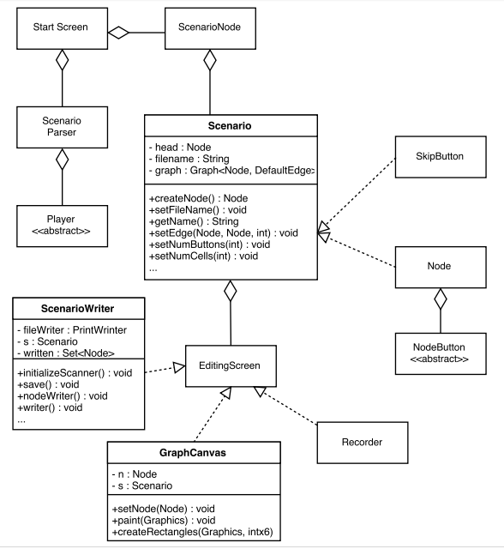

*Figure 1*

## 2.3 System Operation

Figure 2 is a typical sequence diagram for a user session. The purpose of this diagram shows you how the inner workings transpire within what we see from the start screen “Start” before it gets to the “Editing” and then onwards. With that said, there’s also methods detailing how its translates and why.

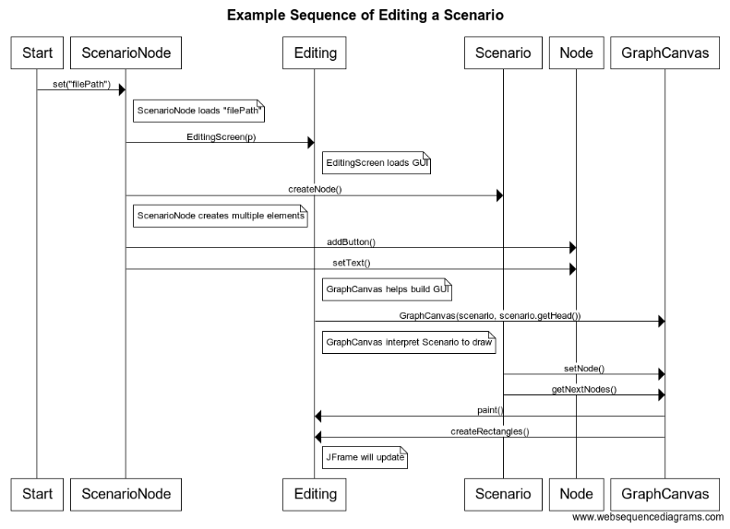

*Figure 2*

# 3.0 System Architecture

## 3.1 System Design

Figure 3 is a block diagram below shows the different parts of the system and how they typically interact with each other, this starts from the user, and ends with the final product.

User

Starting Screen

Create File

Import File

Editing Screen

Recording

Export File

## *Figure 3*

# 4.0 Component Design

This section will be a break down of what each functional component of the program does.

**A.1 Create Scenario**

* Prompts User for number of TBB cells and buttons to use in the scenario
* Prompts User for the file string, as well as the file name

**A.2 Import Scenario**

* Opens an existing TBB scenario text file from the Start Screen, and into the program.

**C.1 Create Audio File**

* The user must press “Start Recording”
* The system will record audio from the default microphone for the specified length and save it as a .wav file
* The user will then be prompted for the name they desire once “End Recording” is pressed, which will then direct them back to the editing screen.

**B.1 Add Feature to Scenario**

* User selects feature to add to scenario from drop down list
* Adds selected feature to scenario, may prompt user for input depending on which option is selected

**B.2 Test Scenario**

* Tests the imported/created scenario in a virtual TBB client

**C.1 Export Scenario**

* Exports scenario as a text file

# 5.0 User Interface Design

The Authoring Application user interface features a intuitive display depicting where your manipulations stand, how they coordinate, how they break off and so on.

On the start screen is 2 main buttons denoted “Choose Existing File” and “Create a File”. Further, on the Editing Screen, you are given buttons to create new nodes for file manipulation, as well as buttons choosing how many buttons will be accessible while running, and a button going back to the main menu and the run button itself.

There is a drop-down menu for each of the new layers of manipulation for each manipulation that has a variety of features that the user can add to their TBB text file, some of these features require input will have a pop up window requesting user input.

# Maintenance Scenarios

Should you need to rearrange any of the GUI components, please see the start screen as this is the screen detailing if you should open or create a new scenario.

Should you want to change the order of the manipulations, this is done under the EditingScreen.java GUI.

Should you need to change any of the code regarding the backend for how you create the scenario or open it, please see the StartScreen.java code for details as there are comments for ease of access and understanding.

Should you need to change any of the code relating to the order of the nodes, please see the GraphCanvas.java and the EditingScreen.java code for details as there are also comments for ease of access and understanding.